* Differentiated Professional Developments
* Coaching Cycles
* Instructional Rounds
* Peer Observations
* Grade level planning around student work
* Backwards Map Planning

Strengths:

* Daily use of Tier I Curriculum
* Common grade level planning time
* Digital Resources

Gaps:

* Scaffolding within Tier I Instruction
* Student Data Analysis
* Coaching Cycles

fda

**Goal: By June 2025, we will increase the percentage of students on grade level for ELA NSCAS from 29% to 34%.**

**Strategy:**

What will we focus on to

achieve our goal

-

our

commitments?

**Actions:**

To do list: things we need to do to

implement our strategies

)

Lead with a verb

(

**Success Criteria:**

What are we expecting to see and hear from

the leadership team and teachers?

**Progress**

**/Outcomes:**

What evidence will we use to monitor

student progress?

**Professional**

**Development:**

What will you teach to support effective

strategy implementation?

Reflect Connect & Create

**REFLECT:**

As you reflect on what you’ve learned today (in your Leadership of SIP)

identify your areas of strength and gap areas.

**CONNECT:**

As you look at your gaps/strength, where will you go next in your

leadership actions?

**CREATE:**

1.

How will you leverage your team?

2.

What data do you need?

3.

How are going to review the data with your team?

4.

What pieces do you need to revisit in your plan?

5.

How do you need to revise your plan?

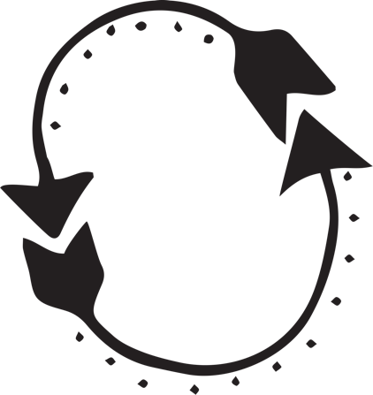

-Grade level planning on student artifacts

-Backwards planning on common assessments

-Scaffolding

- Tier I Look Fors

- Backwards planning using the HMH assessments

- Meeting student needs through scaffolding

* Digital Resources
* HMH Assessment dashboard
* Grade-appropriate tasks
* MAP growth
* Reading levels to increase
* Coaching evidence will reflect best practices.
* Checks for understanding.
* Use of Language Frames
* Use of Collaborative conversations
* Identify strengths and misconceptions around student artifacts.
* Plan for unit of study using common assessment.
* Identify a scaffold to support the learning.